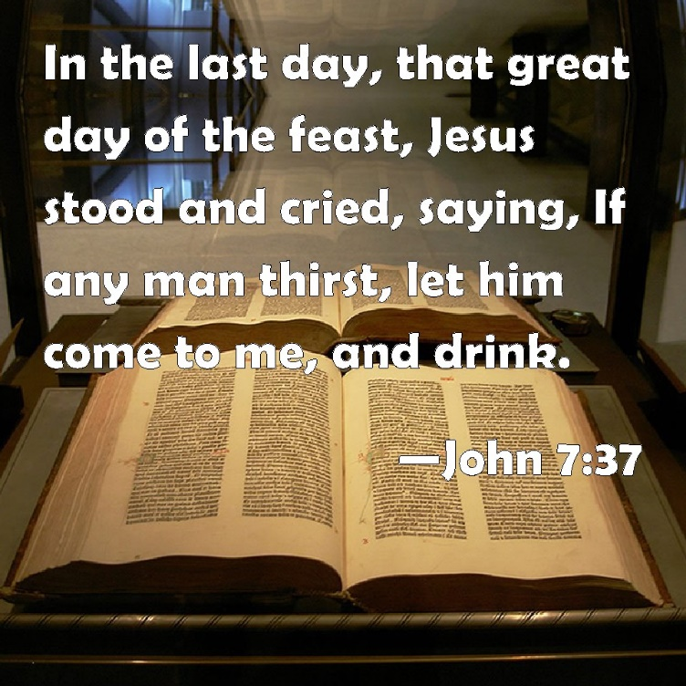
Our scripture reading this morning is from the Gospel According to John, where we've been reading over these past Sundays. We read in John's Gospel, and today in chapter seven... and a number of verses, which we'll read from the beginning of the chapter, which you'll find on page 892 of the Pew Bible. And again, it will be helpful for you to have the Bible open before you at that place, page 892 of the Pew Bible. We'll read first of all, verses 1 through 14, and then, verses 37 through 39.
"After this, Jesus went about in Galilee. He would not go about in Judea because the Jews were seeking to kill him. Now, the Jews' Feast of Booths was at hand, so his brothers said to him, 'Leave here and go to Judea that your disciples also may see the works you are doing, for no one works in secret if he seeks to be known openly. If you do these things, show yourself to the world.' For not even his brothers believed in him.
"Jesus said to them, 'My time has not yet come, but your time is always here. The world cannot hate you, but it hates me because I testify about it that its works are evil. You go up to the Feast. I am not going up to this Feast, for my time has not yet fully come.'
"After saying this, he remained in Galilee. But after his brothers had gone up to the Feast, then he also went up, not publicly but in private. The Jews were looking for him at the Feast, and saying, 'Where is he?' And there was much muttering about him among the people. While some said, 'He is a good man.' Others said, 'No, he's leading the people astray.' Yet for fear of the Jews no one spoke openly of him.
"About the middle of the Feast, Jesus went up into the temple and began teaching."
And then in verse 37, "On the last day of the Feast---the great day---Jesus stood up and CRIED OUT..." And I want here to follow the reading that you'll find in the footnote. Let me read the words using the reading that's found in the footnote. "On the last day of the Feast, the great day, Jesus stood up and CRIED OUT, 'If anyone THIRSTS, let him come to me; and let him who believes in me drink. As the scriptures have said, out of HIS HEART (i.e., the MESSIAH’S HEART) will flow RIVERS OF LIVING WATER.'
"Now, this he said about the SPIRIT, whom those who believed in him were to receive; for as yet the Spirit had not been given, because Jesus was not yet GLORIFIED."
I wonder if it struck you as we've been reading through The Gospel According to John as it has struck me---I think, more forcefully than any other time in my life I've read through the Gospel of John---that we are today only one third of the way through the narrative of Jesus' life and ministry according to John. And yet already there is a very, very serious plot to MURDER Jesus.
We are only in the seventh chapter, but already we have learned that there are those who are seeking to MURDER Jesus. And indeed, he is particularly conscious as he tells us on more than one occasion in this chapter that there are those who want to kill him. Of course, the idea is ridiculous. Who would want to kill Jesus? And people said that to him. The idea is LUDICROUS. People wanting to kill you. And yet, as John unfolds the wonder of the life and ministry of Jesus, obviously early on in these three years of ministry, there were those who found the pressure of Jesus' teaching so powerful on their spirits that they wanted to resist him to the bitter end. And of course, as the gospel narrative goes on, this is exactly what we discover happened. It is John's way of saying, as we have already seen in his gospel, at the end of the day, there really are only TWO THINGS that you can do with the Lord Jesus. 1) You must either EMBRACE HIM by faith as your savior, master, and Lord. Or alternatively, 2) you will eventually find the very mention of his name INTOLERABLE to you, and you will either switch him off your life mentally, or as these men known for their obedience to God's law for their rectitude and their righteousness eventually did--- literally and physically---took him and had him MURDERED.
And so, as Jesus is encouraged to go up to the Feast of Booths by his brothers, who John tells us, themselves did not believe in him. They were simply playing with him: "If you're really able to do these things, you should go to Jerusalem and do those things in the most PUBLIC way." John tells us of how Jesus eventually does go to this Feast, the Feast of Booths. And as the seventh chapter unfolds, it tells us a story of the mounting OPPOSITION to Jesus and about the widespread CONFUSION about Jesus. And then, eventually in verses 37 to 39, the marvelous INVITATION of Jesus. And these are the THREE THINGS I want us to think about this morning. The first two very briefly, and the third, at a little greater length.
1. A Mounting OPPOSITION to Jesus
This is a chapter about the 1) MOUNTING OPPOSITION against Jesus. It's already present in chapter five. We are told of those who wanted to plot against him. But notice how that opposition MOUNTS here, verse one, "He would not go about Judea because the Jews were SEEKING TO KILL HIM." Again, in verse 19, a similar kind of thing, "Has not Moses given you the law? Yet none of you keeps the law. Why do you SEEK TO KILL ME?" Again, in verses 25 and 26, "Some of the people of Jerusalem said, "Is not this the man whom they SEEK TO KILL?" So, it was apparently well-known what was afoot. Verse 30, "They were seeking to ARREST HIM, but no one laid a hand upon him." And verse 32, "The Pharisees heard the crowd muttering these things about him, and the chief priests and Pharisees sent officers to ARREST HIM."
On FIVE separate occasions in this chapter, John records the way in which OPPOSITION was mounting against the Lord Jesus Christ. And there was, as you notice, much MUTTERING about him behind the scenes. It's a little indication to us, actually, that it's what happens BEHIND THE SCENES that really tells us what people really think about the Lord Jesus Christ. It's what happens BEHIND the eyes, what happens BEHIND the demeanor, what happens BEHIND the words: the muttering and the grumbling of the heart that was mounting against the Lord Jesus Christ. My friends, we always ought to be conscious---would to God this would dawn upon us---that it is always DANGEROUS to side with Jesus. But when anyone sides with Jesus, there is going to be MUTTERING and GRUMBLING about them. That if you are going to side with Jesus, people are going to speak about you and defame you with Jesus behind your back, because they cannot speak well of YOU without speaking well of JESUS. And they cannot speak well of JESUS without speaking well of THOSE who love, and trust, and follow the Lord Jesus. And so, this is a very searching narrative about MOUNTING OPPOSITION against Jesus.
2. A Widespread CONFUSION About Jesus
But 2) it's also a narrative that tells us about a rather WIDESOREAD CONFUSION there was about Jesus. The question apparently on many people's lips was the question, "Who is Jesus?" And if my mathematics is correct---which is not always the case---if you look down through verses 11 to the end of this chapter, you will notice that there are no less than NINETEEN question marks.
That might just be the most concentrated number of QUESTION MARKS anywhere to be found in the gospel. And those question marks are all actually about Jesus. Either PEOPLE questioning about Jesus, or JESUS questioning people about himself. QUESTIONS, QUESTIONS, QUESTIONS! But you see, the wonderful thing about that is that when Jesus comes in POWER---as he was coming in power among the people in those days and demonstrating his DEITY and his gracious HUMANITY, his saving and keeping power---there are always going to be QUESTIONS. It's a little indication about the difference between the church WITH the power of the Holy Spirit, and the church WITHOUT the power of the Holy Spirit. When Jesus IS PRESENT among his people in the POWER of the Holy Spirit, then people ASK QUESTIONS. When Jesus is NOT PRESENT in the POWER of His Holy Spirit among his people, NOBODY outside ASKS any QUESTION.
And so, we ought to understand that in situations where people are TALKING about Jesus---even if they are CONFUSED about Jesus... in a sense even if they are wrong about Jesus---it can be the EVIDENCE of the power of the PRESENCE of Jesus Christ. How different are our churches TODAY, are they not? Where we have to employ every conceivable technique to try to find a way to get people to listen to what we have to say about Jesus? But when Jesus is PRESENT in the power of His Holy Spirit, WE are not the ones who are asking the questions. The WORLD is coming to us and ASKING the QUESTIONS about Jesus. "Who is he? Is he who he really said he was? Did he do what he really said he did? Is he the Savior the Bible promises him to be?"
And so, there's this amazing CONTRAST. In a way, we should find it almost FRIGHTENING---but at the same time INSPIRING---that TWO THINGS are happening SIMULTANEOUSLY for one and the same reason. 1) There is enormous HOSTILITY to Jesus. My friends, I say again, wherever Jesus is truly present---the REAL Jesus---he always evokes enormous HOSTILITY eventually. 2) And yet at the same time, the QUESTIONS are being asked. And there are those who are SEEKING and there are those who are COMING.
3. A Shouted INVITATION to Come to Jesus
And it's this that brings us to the THIRD and the MAIN point of this passage. Yes, there is mounting opposition against Jesus. Yes, there is widespread questioning of Jesus. But here in verses 37 through 39 is the CENTERPIECE of this chapter: this marvelous INVITATION TO COME TO JESUS.
And you should notice a very ARRESTING and UNUSUAL thing. Twice in this chapter---using the same verb, although it's translated differently---in verse 28 and in verse 37... twice in this chapter we read a most UNUSUAL STATEMENT about the Lord Jesus: "HE SHOUTED OUT." Now why is that unusual? Because one of the Bible texts by which Jesus lived, as Matthew 12 tells us, is that beautiful text in the prophecy of ISAIAH that says that, "He WOULD NOT lift up his voice in the streets." He wouldn't draw attention to himself in an unseemly way. And so, the voice of Jesus is characteristically a tender voice---a voice of GRACE, a voice of GENTLENESS. But here in this event, there are two moments when Jesus DEMANDS to be heard. When he is saying something which is obviously of such enormous importance to him, that he stands and RAISES HIS VOICE and directs all hearers' attention to HIMSELF.
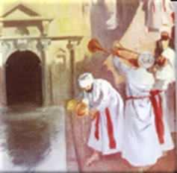
In order to understand what Jesus is saying, we need to understand that He says these words in verses 37 through 39, "On the last day, the GREAT DAY of the Feast of Booths." Now, the Feast of Booths was that annual festival where the people would gather in Jerusalem, but they would live in artificial tents to celebrate the days when they passed through the wilderness and God provided them with water to drink, with manna to eat, and with the cloud of light that led them through the wilderness eventually into the Promised Land, how for 40 years God PROVIDED for them. Despite all their sinfulness, he provided them with everything that they needed. And the Jews celebrated this Feast in a SPECTACULAR way. Each day of the seven days of the Feast, they would gather, and they would be led by the priests down to the POOL OF SILOAM. And there, they would gather WATER, and they would celebrate by speaking, and chanting, and singing some of the Old Testament texts about the WATER that God provides for his people: "With joy will we draw WATER from the wells of Jerusalem," from Isaiah chapter 12, and other texts in scripture?
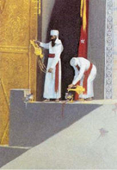
And then when the priests had gathered the WATER, they would march up to the temple. And there, they would go round the altar, and the priests ceremonially would pour out this WATER from Siloam into the base of the sacrificial altar. It was a sign of longing for God to give the WATER that would finally satisfy them... that they believed the MESSIAH would give. And then on the last day, THE GREAT DAY, they would go round the altar, and round the altar, and round the altar until they've gone round the altar SEVEN TIMES. And then, with great drama on that last day of the Feast, the WATER would be poured down into the base of the altar. And there would be this kind of stunned silence--- as there sometimes is, isn't there at the end of some great occasion when it's over. And the Feast was over for another year, and the water was gone, and they were still THIRSTY. The MESSIAH had not come, they were still in desperate need. How could their sins ultimately be forgiven?
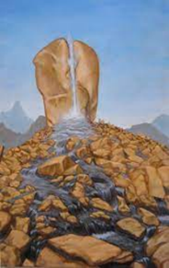
And on the LAST DAY OF THE FEAST, when the drama had been finally enacted, Jesus said with a LOUD VOICE, "Is there anyone here who is still THIRSTY? Is there anyone here who understands what the Old Testament texts mean when they say, 'Are you spiritually THIRSTY?' Is there anyone here who is THIRSTY??? Then," says Jesus, "let him come to ME, and let him who believes in ME, drink from ME!!! As the scriptures have said, 'Out of HIS HEART,'... Meaning I think, out of JESUS' HEART,... 'will flow rivers of LIVING WATER.' " And John adds, "He spoke here about the HOLY SPIRIT, who had not yet been given, because Jesus had not yet been GLORIFIED." And you see what he's saying. He's saying, "All the DRAMA, all the RELIGION, all the LITURGY, all the RITES of the OLD TESTAMENT SCRIPTURES... don't you see that they are all making you THIRSTY for the REAL THING? And I am the REAL THING. It's from ME that rivers of LIVING WATER will flow to you to satisfy your deep SPIRITUAL THIRST.” And of course, it's not coincidental that it's in John's Gospel exclusively that we are told, when the soldier pierced Jesus' side right into WITHIN HIM, "And there flowed from within him, not only blood," says John, "but water." You see how John must have put these TWO THINGS together. It's from his WOUNDED SIDE that the satisfaction of our DEEPEST needs comes. It's when Jesus is CRUCIFIED and EXALTED as our savior that he SENDS his Holy Spirit into our hearts to bring HIS OWN PRESENCE there in order to satisfy our deepest needs. Of course, you know what the people remembered, don't you? They remembered how the people in the wilderness had CRIED OUT to Moses and said, "We are THIRSTY. We are THIRSTY and we are dying in the desert." And God came down and as it were, stood upon a ROCK, and smote the ROCK in the wilderness. And out of the center of the ROCK, there flowed the WATERS that would meet the physical needs of the people.
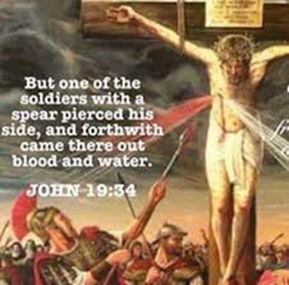
And John, I think, is saying to us, "That's just a picture of THE LORD JESUS CHRIST and how, upon the cross of Calvary, God would SMITE the ROCK again. And from his WOUNDED SIDE would flow the BLOOD that would cover our SIN, and the WATER that would symbolize the HOLY SPIRIT, who would satisfy our deepest spiritual needs by 1) bringing us to FAITH IN CHRIST, and then, as Jesus puts it here, 2) by bringing us to DRINK OF JESUS CHRIST.”
And so, you see, John says there are THREE THINGS that always go together. They are never separated from one another. 1) NUMBER ONE, the QUENCHING of my spiritual needs by THE WATER OF LIFE that the Lord Jesus gives to me. 2) NUMBER TWO, the gift of the Holy Spirit to bring the BLESSINGS OF JESUS into my heart. 3) NUMBER THREE, the GLORIFYING OF THE LORD JESUS in my life.
Of course, when John said, "He was speaking about the SPIRIT who was NOT YET GIVEN," literally he says, "Who was not yet until Jesus was GLORIFIED." He's thinking about how the GLORIFIED Lord Jesus would pour out his Holy Spirit on the day of Pentecost and satisfy the needs of those THIRSTY ONES on the day of Pentecost who were CRYING OUT for their need of forgiveness to be satisfied.
This Has Application to Us
But you see what took place there in HISTORY takes place here in my PERSONAL AUTOBIOGRAPHY. And these THREE THINGS always go together. 1) The satisfying of my SPIRITUAL NEEDS in Jesus Christ, 2) the gift of the Holy Spirit GIVEN TO ME by Jesus Christ, and 3) the HONORING, and GLORIFYING, and EXALTING of the Lord Jesus Christ in my heart.
And we can ask the QUESTION in any one of THREE WAYS. 1) Is Jesus GLORIFIED in your heart? 2) Have you RECEIVED the Holy Spirit? 3) Is your SPIRITUAL THIRST being met by Jesus Christ? And if the answer to ONE of these is, "YES," then the answer to ALL of these is, "YES." It's of this very thing that Horatius Bonar so beautifully wrote, "I heard the voice of Jesus say, 'Behold, I freely give the LIVING WATER. Thirsty one; stoop down, and DRINK , and LIVE.' I came to Jesus, and I DRANK of that life-giving stream; my THIRST was QUENCHED, my SOUL REVIVED, and now I LIVE in Him."
Today, Jesus says, "Is there anybody here who is THIRSTY?" Then, come to HIM and DRINK. And from WITHIN JESUS, flowing into YOUR HEART, will come the HOLY SPIRIT like rivers of LIVING WATER by which you will be satisfied in THIS LIFE and in THE LIFE TO COME. And all your need for forgiveness, and pardon, and satisfaction, and new life will surely be met. Oh, come to HIM, and DRINK, and be satisfied. "Our heavenly Father, we thank you again for the riches of our Lord Jesus Christ---that he is able to satisfy all of our needs... to bring us the forgiveness of our sins, to bless our lives with the rich blessings of his grace. Save us, Lord Jesus, from looking anywhere else but to YOU for pardon, to anywhere else but the gift of your HOLY SPIRIT for satisfaction, to anyone else but your dear HEAVENLY FATHER for acceptance and blessing. And draw us near to yourself, we pray, as we sing to you and as we gather around your table together. Bless us, we ask, for your great name's sake. Amen."

