2 Samuel 7:23-24
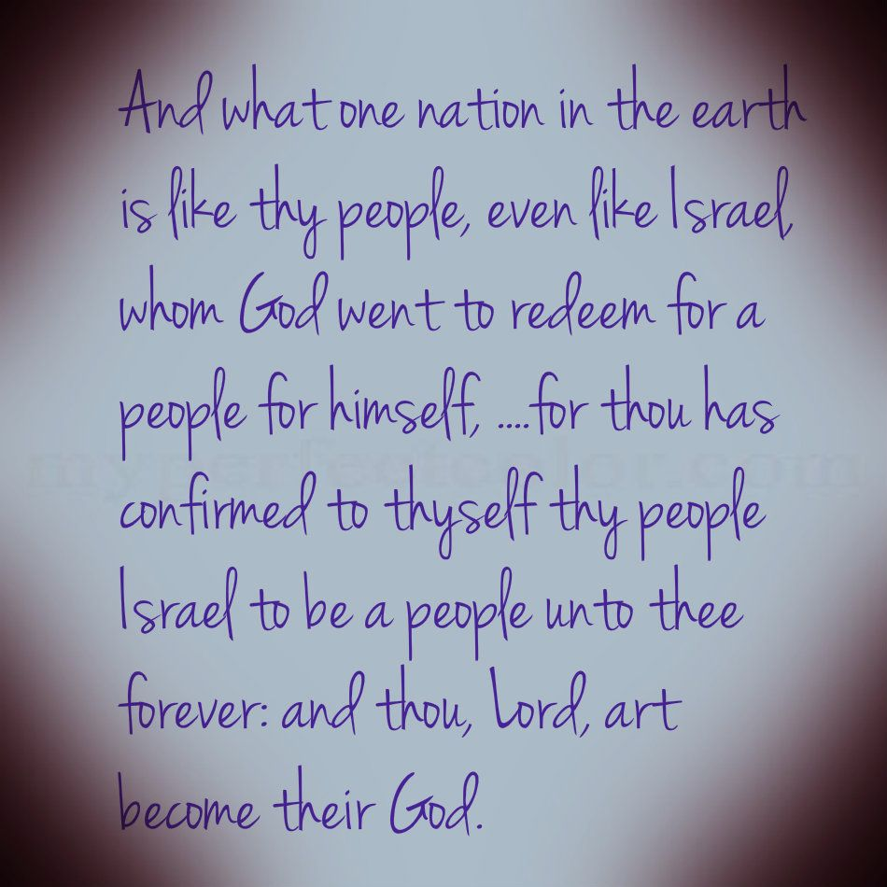
Let us pray. How often, our Lord, we have been in the goop---in the muck, and you have pulled us out of many waters and you have set our feet upon a rock; and how often, oh Lord, we have been walking through dangers---often seen, but perhaps more often unseen, and still we have been able to say with your word, "Though I walk in the midst of trouble, you preserve my life. And how often perhaps you have also taken us through the thick of darkness and there's been nothing that we could feel except the grip of a nail scarred hand. And so, we thank you, oh God, that we are a DELIVERED people; and therefore, we are thankful people. And we give you thanks also for what we sometimes call your ordinary gifts, as well for your word. We pray that you would fasten our minds upon it for Jesus' sake. Amen.
Our text tonight comes from Second Samuel chapter seven, and the text is verses 23 and 24... but we'll be reading 2 Samuel seven, verses 18 to 24. This is a part of King David's prayer as he responds to Yahweh's COVENANT PROMISE of his ongoing dynasty. Two Samuel chapter seven beginning at verse 18, and then the last two verses will be our text.
“Then King David went in and remained before Yahweh and said, ‘Who am I, Lord Yahweh, and what is my house that you have brought me to this point? And this is yet a small matter in Your eyes, Lord Yahweh, for you have even spoken of your servant's house for a long time to come, and this is the plan for mankind, Lord Yahweh. And what more can David add by speaking to you. And you have singled out your servant, Lord Yahweh, because of your promise. And in line with your own decision, you have done all this greatness to make your servant know it. Therefore, you are great, Lord Yahweh, for there is no one like you and there is no God beside you in line with all we have heard with our ears. And who is like your people---like Israel---a unique nation in the earth, whom God went to REDEEM for a people for himself, and to make for himself a reputation, and to do for them grand and fearful deeds by your driving out nations---each with its own gods---from before your people whom you REDEEMED for yourself from Egypt. So, you established for yourself your people Israel as your very own people forever; and you, Yahweh, have become their God.’ "
When I was in graduate school, there was a fellow who was from Australia and who had done some of his upper-level studies in England. And because of that I asked him about a certain biblical scholar in England who had written a commentary that I thought was a rather helpful and well-done piece of work. And I asked this Australian fellow about him, since he seemed to have been acquainted with him; and he said he was a rather ordinary chap.
That's a little bit of a come-down---whatever you are, you don't want to be a rather ORDINARY CHAP. It's sort of like if you read book reviews, for instance, every once in a while, you read someone with a review that calls a volume 'a workmanlike book'. That's a KISS OF DEATH. That's like the southern...some of you southerners say, "Bless his heart." That's not a blessing, that's a CURSE. Whatever you have and you put out a book, you don't want someone to call it, 'workmanlike'. And you don't want to be called an 'ORDINARY CHAP'.
But it's hard when you come to God's people to recognize them as anything SPECIAL sometimes, doesn't it...because sometimes because of what God's people DO and sometimes because of what HAPPENS to them. Well, 1) you think about what God's people DO. Sometimes they can be downright nasty, they can be cane raising, they can make all kinds of trouble. But 2) also they can be saddened by huge waves of TROUBLE that wash over them as well. And perhaps, 3) because they're NOT usually among the movers and shakers who impress you with how slick and sharp they are. But the Bible gives you a DIFFERENT view.
We Are a MIRACLE People
The Bible's view is God's people are a MIRACLE PEOPLE, and you can pick that idea up from the most out of the way places---like snooping on someone else's prayers. That's really what we have here in our text, because David's PRAYER RESPONSE, 1) first of all there was God's REVELATION and PROMISE of David's ongoing dynasty and kingdom in two Samuel seven, eight to 16; and 2) then in verses 18 to 29 was DAVID'S PRAYER RESPONSE to that promise.
And in this prayer response there are TWO SECTIONS. 1) There's a PRAISE SECTION---verses 18 to 24, and 2) there's a PETITION SECTION---verses 25 to 29. And part of David's praise---verses 18 to 24---consists of verses 23 and 24, where David is marveling over Yahweh's people. GOD'S PEOPLE, he says are AMAZING. And I want you to focus on verses...2 Samuel seven verses 23 and 24.
- We Are a PURCHASED People
Well, they're amazing 1) FIRST of all because... and you are made and because you're a PURCHASED people. Look at verse 23. "Who is like your people (like Israel), a unique nation in the earth whom God went to REDEEM for a people for himself, and to make for himself a reputation, and to do for them grand and fearful DEEDS by your driving out nations---each with its own gods---from before your people whom you REDEEMED FOR YOURSELF from Egypt.”
I'm aware of the fact that verse 23 is difficult and it appears differently in different translations, but that's a fairly reasonable translation there. But they are a PURCHASED people. Did you pick up the word REDEEM, used twice in the first part of the verse and then in the last line of the verse. And in that last line it picks up TWO ASPECTS of what redeemed refers to. "Your people whom you redeemed FOR yourself FROM Egypt." Redemption is FROM and FOR, those two aspects. Now the dictionary definition of this verb translated 'REDEEM' here is that it refers to bringing about a TRANSFER OF OWNERSHIP through the PAYMENT OF A PRICE. The payment of the price doesn't seem to be prominent here, perhaps in this text, but you do have the 'TWO POLES OF REDEMPTION', we might call this. You notice he's referring (look at the last line of verse 23)... He's referring to Israel's deliverance and REDEMPTION FROM EGYPT, Exodus 12 and 13 and 14, et cetera. Now you see these two aspects, 'FROM Egypt,' and 'FOR yourself... FOR Yahweh'.
So, those are the two aspects, LIBERATION, or liberated from bondage, to belong to a NEW MASTER. Hence REDEMPTION involves... or, being redeemed involves LIBERATION and POSSESSION. It focuses on God's power to SMASH EGYPT'S CHAINS, and it focuses on God's purpose to BIND ISRAEL TO HIMSELF. And the latter (binding Israel to himself) has the STRESS in the last part of verse 23, "Your people whom you REDEEMED FOR YOURSELF from Egypt for GOD’S OWN POSSESSION."
Now we'll come back to this text momentarily, but you have the same aspects of the matter in the NEW TESTAMENT. For instance, Titus two verse 14. Do you recall what that says? It talks about, "Jesus Christ who gave himself for us to REDEEM us FROM all lawlessness, and to purify FOR HIMSELF a people FOR HIS OWN POSSESSION who are zealous for good works." To redeem FROM and FOR. So, they're both aspects. Redemption involves FREEDOM but not INDEPENDENCE. It's important to notice!
Now, the matter of a PAYMENT OF A PRICE is not missing in the OLD TESTAMENT either. You may wonder, "Well, what was the payment of the PRICE that was involved in redeeming Israel from Egypt?" Now, it may have been the death---the DEATHS---of the firstborn sons of the Egyptians in the 10th plague in Exodus 12 and 13. That could have been looked upon as the PRICE of Yahweh's REDEMPTION of his people. But it's LARGER than that. You run into texts like Isaiah 43 and verses three and four, where God speaks of the PRICE he paid. You don't have to turn to that, but I'll refer to it. Isaiah 43, verses three and four. It's where Yahweh calls himself, "The holy one of God, your savior," referring to his remnant people. And then he says... and I'm going to change the ESV here, because I don't think it has it exactly as well as it could be put. There are two verbs. One is a PAST TENSE: "I HAVE given." And then in verse four there is ANOTHER TENSE of the verb, you might say, which is sort of, "I WOULD give." I think those are the two aspects.
So, what's he say? He says in Isaiah 43, 3, "I have given Egypt as your RANSOM, Cush and Seba," (those are south of Egypt,), "in EXCHANGE for you, because you were precious in my eyes and honored, and I love you. I would give mankind in EXCHANGE (in return) for you, and peoples in EXCHANGE for your life."
Now there he is talking about the REDEMPTION at the exodus. "I have given Egypt as your RANSOM, Cush and Seba in EXCHANGE for you." There's a sense in which at delivering his people from Egypt, it's as if Yahweh says, "I gave Egypt, I gave Cush and Seba... I gave East Africa for you." There was a PRICE PAID in that REDEMPTION. But then he says, "Because you were precious and honored and I (emphatic!!) love you, I would give MANKIND," not just men, but it's ‘Adam’---I think it means MANKIND. "I would give mankind in return for you and peoples in EXCHANGE for your life." As if Yahweh is saying, "And if I had to, I would give a world for you. No price is too high for me to pay in REDEEMING.”
I had a friend, and his name is Norman Rowe. He was also a ruling elder in one of our congregations. And one Sunday morning Norman was teaching an adult Sunday school class and he referred to a situation where... I forget exactly the point that he was illustrating, but it was the difference that very small things can make. And it was about a woman and wife who was over in Paris or somewhere, and she was shopping and ran on to some... I don't know if it was some kind of clothes, or whether it was a piece of furniture... maybe it was something that was immensely expensive... but she craved it. So, she cabled... or telegraphed... I dunno how you do that... but, her husband back in the states, and asked him if you could get this. And he cabled back, "No," he wrote down for the cable operator. "No, price too high. That is, "No, price too high." But you know what cable and telegraph people are? They're a scurvy bunch, and sometimes they don't pay too much attention to detail. Maybe they don't have enough caffeine and they get a little drowsy, And the guy messed it up massively. There was a HUGE matter there. It's called the COMMA and he left it out. "No price too high." And she indulged herself.
But, you see, that's what Yahweh is saying as he looks back on how he delivered his people from Egypt. "I would give MANKIND in return for you, and PEOPLES in exchange for your life. There is no price too high!" And when you change testaments, it's the same pattern, isn't it? It's the same with what I call 'the goosebump theology' of 1 Peter one 18 to 19. You remember in that passage in 1 Peter one verse 17, Peter says, "If you call God 'Father', who judges all men without partiality," et cetera, "past the time of your sojourning here in fear." And then, how does he explicate that? How does he support that idea of passing your time in fear? Verse 18, "Knowing as you do that it was not with perishable stuff---with silver and gold---that you were RANSOMED from your empty way of life, passed down from your forefathers, but with COSTLY BLOOD---like that of a lamb without blame and without spot---even the blood of Christ." What is it that causes the cold goosebumps to break out on your spine? It's realizing the VAST COST of the price that was paid. And it ought to cause you to pass your time in trembling fear.
It's the same in 1 Corinthians six verses 19 and 20. You remember Paul is telling you why you can't go around shacking up with prostitutes if you're a Christian. He says, "And you are not your own, for you were BOUGHT with a PRICE." You are possessed by another who has REDEEMED you FROM and TO himself. You're a PURCHASED people. Years and years ago and there was in the 'Daily Bread' devotional guide a story about a missionary from Africa by the name of Jay Alexander Clark. And he tells (or told) of a native who had been mangled by a lioness and almost killed; and Mr. Clark had rescued this man and cared for his wounds. And when he recovered, he'd returned to his home village. After a short time, he returned and he said to Mr. Clark, "The law of the African forest is that the RESCUED belongs to his REDEEMER. I almost died, but now because of you I'm alive, I AM YOURS. Here are my six wives and my children and all my cattle. You can do with me and with them as you like." He understood REDEMPTION: he belonged to ANOTHER.
And that's what makes you a MIRACLE PEOPLE! You are a PURCHASED PEOPLE.
- We Are a PRESERVED People
But then you are also, SECONDLY, a PRESERVED PEOPLE. Look at the first part of verse 24, where David said, "So you established for yourself your people Israel as your very own people FOREVER." You are a PRESERVED people. There are two code words here in the text. The first of verse 24. 1) One of them is, 'ESTABLISHED,' that verb 'ESTABLISHED'. It means 'to set down', it means 'to put in place', means 'to (you might say) anchor', et cetera. "You ESTABLISHED for yourself, your people Israel." And that verb is used three times earlier when Yahweh made his promise of the kingdom to David. It's used in verses 12, 13, and 16.
And then 2) this word 'FOREVER'. "YOU established for yourself, your people Israel as your very own people FOREVER." And that word is used three times in the promise to David: once in verse 13, twice in verse 16. You get some sense of it, if you just look at verse 16 where Yahweh said to David, "And your house and your kingship shall be made firm FOREVER before me. Your throne will remain ESTABLISHED FOREVER." So, words that David picks up here in his petition in the first of verse 24. So, David recognizes that ISRAEL will be--- or is---as PERMANENT as his DYNASTY that Yahweh promised him---not because they're so durable but because God intends to keep them. God's PEOPLE and David's DYNASTY are SURE THINGS. They are God's FOREVER ENTITIES. They are a PRESERVED PEOPLE.
Now when you go into the New Testament, you breathe the same air that God's people are a PRESERVED PEOPLE. They are kept. Oh yes, there is all that comes about for them, 'fightings and fears within and without', as the hymn says, and all of that... all sorts of DANGERS and PERILS. It's a wonder, you might say, that they ENDURE at all.
Leon Morris---and I know I've told you this before---but Leon Morris said he'd always liked the story of the bomber crew from World War II that went on a raid over enemy territory, and they ran into heavy flack and they were hit a number of times, and there was a problem with the steering. And so, the pilot asked the rear gunner if there had been a hit in the rear of the plane and the gunner replied, "There's a three by five hole in the left horizontal stabilizer and elevator." Then the gunner anxiously asked, "Will we be able to make it home?" The pilot said, "No sweat."
Eventually they made it; but when they landed, the plane skidded and skewed alarmingly. And when they got out and looked at the plane, the pilot exploded. He said to the rear gunner, "When you said three by five, I thought you meant 'inches', not 'feet'." And the rear gunner said, "I thought you might've gotten that impression, but you were busy with the aircraft, and I didn't want to bother you with details."
But you see it's worse. Our perils are WORSE sometimes than we think, and yet we are KEPT. God's people are a PRESERVED people, and that's what Jesus’ assurances give to us, isn't it? John 6:37. "All that the Father gives me will come to me, and the one who comes to me I will never, ever cast out." And he goes on in John 6:39. "The will of the one who sent me is that, of all that He has given me, I should lose nothing, but raise it up at the last day."
Jesus' people are a PRESERVED people. You remember that text in John 10 and verse 29. The usual translation is, "The Father, who has given them to me, is greater than all, and no one can snatch THEM out of the Father's hand," 'them' being Jesus' sheep or Jesus' people. But there's another reading in the Greek text that maybe has the edge there, not, "My Father, who gave them to me, is greater than all," but rather that text says, "What the Father has given me is GREATER than all. No one's able to snatch them out of the Father's hand."
What does he mean? He means what the Father has given me---my sheep, my people---means MORE than anything. It's a SUPREME VALUE, and NO ONE is going to destroy them. That's the way Jesus assures us. He never tires of assuring us. Those of us with many a conflict, many a doubt... with many dangers, toils and snares (as another hymn says) ... and we never tire of hearing that we're HELD in the grip of the lamb, nor do we tire of hearing our shepherd's ASSURANCE on that score. You're a MIRACLE PEOPLE because you're a PRESERVED PEOPLE.
- We Are a PRIVILEGED People
But then THIRDLY, you're a miracle people because you're a PRIVILEGED people. The last of verse 24 when David goes on to say, "And you, Yahweh, have become their God. So, you established for yourself your people Israel as your very own people forever, and you Yahweh have BECOME THEIR GOD." Now, that's part of the covenant formula we sometimes call it the Lord PROMISES to be God to his people and they will be his people.
And that's what David is picking up on here. "You Yahweh have become their God." Now, that was the PROMISE that---in those terms and with that formula---that Yahweh made to Abraham in Genesis 17, verse seven, "I will be God to YOU and to YOUR SEED after you." It's the same FORMULA basically in Exodus 6:7 that indicates the Lord's intention when he said to Israel, "I shall take you as MY OWN PEOPLE and I will be YOUR GOD." One scholar says that's really a kind of a MARRIAGE contract formula. "There I will take you, and you will be my people as like a fellow---a man---takes a woman, and she becomes his wife." Where we say that that's the same kind of pattern, "I shall take you as my own people, and I shall be your God."
And then, it's also the FORMULA that's used of the projected BLESSING that will come on Israel in Leviticus 26. In the first part of the chapter, Yahweh is talking about the BLESSINGS if Israel is faithful to the covenant and so on. And the climactic one comes in Leviticus 26 verses 11 and 12. This is what it says. You can note it, but you don't have to turn to it... but Leviticus 26:11-12, "And I shall place my dwelling in the midst of you and my soul will not abhor you. And I shall walk around in the midst of you, and I shall be GOD to you, and you will be my PEOPLE... I shall walk around in the midst of you and I shall be God to you and you will be my people." Israel is a people who have Yahweh as their God. He REDEEMS from bondage, and he KEEPS through history. But that's not enough. Yahweh GIVES HIMSELF to Israel to belong to them... to be their God.
It's the same thing in the NEW TESTAMENT. John 14:23. You remember what Jesus said to his disciples, "If anyone loves me, he will keep my word, and my Father will love him, and we will come to him and make our home with him." An INTIMATE God!! You're a PRIVILEGED people. You're not just REDEEMED and purchased. You're not just PRESERVED. You have the PRIVILEGE of intimate relationship. What a covenant God who wants to draw near to you and craves your fellowship.
Donald Gray Barnhouse was for many years pastor of 10th Presbyterian Church in Philadelphia back in the... oh, I don't know, mid 20th century... 1950s, et cetera. And he gave an illustration once. He said, "A widower is left with two small children, so he hires a HOUSEKEEPER to help him. He gives her instructions as to what she shall cook, how she's to keep the house, and how she's to dress and care for the children. He goes about the house from time to time to see that all's in order and that she's properly obeying his rules. He watches her oversight over the children, and if he has to correct her, he does so in a manner befitting the relationship of an EMPLOYER and an EMPLOYEE. After a year or so, he marries the housekeeper. Their relationship is entirely changed. There's a huge difference. What formally was PROFESSIONAL becomes PERSONAL. What formally was DISCRETE becomes INTIMATE, what used to be DISTANCE becomes CLOSE... as a complete change. And that's what this PRIVILEGE is. When Yahweh has become his people's God, it means that he not only purchases and keeps, but he draws near and he comes close, and he nourishes and cherishes his people. You are a PRIVILEGED people. We can't look at ourselves without seeing our God---his power to REDEEM, his intention to PRESERVE and his desire to be INTIMATE.
But as you come to this table tonight, remembering that Jesus said, "Do this in remembrance of me," remember WHAT HE HAS DONE... but also remember WHAT HE HAS MADE YOU---a people unique in the earth.
Oh Lord. It's true what your prophet Ezekiel said. There was a day when, as it were, we were born and we were cast out, and we were unclothed, and we were unwashed, and we were unwanted. And you passed by, and you saw us wallowing in our blood. And you said to us, "Live!" And that's why we are a people. And so, we give you thanks, oh Lord, that you have so looked upon us. And we pray that we would be grateful, now, to come to that table where you welcome your unique people. Amen.

